Address where we can access Node on Engineering Servers.

<http://flip2.engr.oregonstate.edu:3518/>

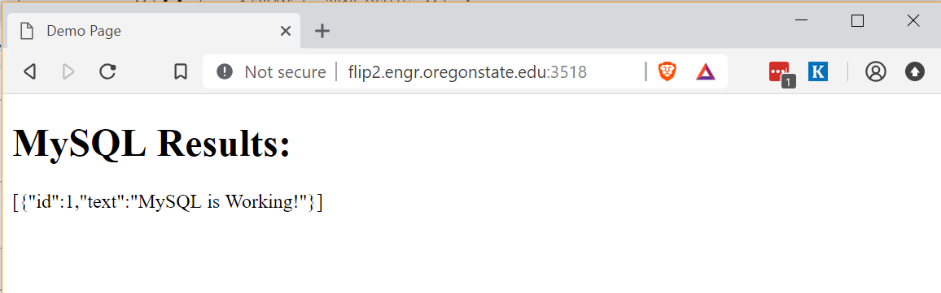

Link to your GitHub repository

<https://github.com/xkuang1738/Winter_2019>

